State Probability
$$p= \left[\begin{matrix}p_{1} \\ p_{2} \\ ⋮\end{matrix}\right]$$

Shorthand Symbols
$$and: ∧$$
$$or: ∨$$
$$not:¬$$
$$S_{2}=\sum_{i}{p_{i}^{2}}$$
$$S_{3}=\sum_{i}{p_{i}^{3}}$$

$$\operatorname{Pr}\left(\text{1 meet 2 at least once in k}\right)=Pr\left(1-2\right)$$
$$\operatorname{Pr}\left(\text{1 meet 2 at least once in k}\text{ after 2 meet 3}\right)=Pr\left(\left(1-2\right)←\left(2-3\right)\right)$$

2 Robots
$$Pr\left(meeting at least once in k step\right)=1-{\left(1-S_{2}\right)}^{k}$$
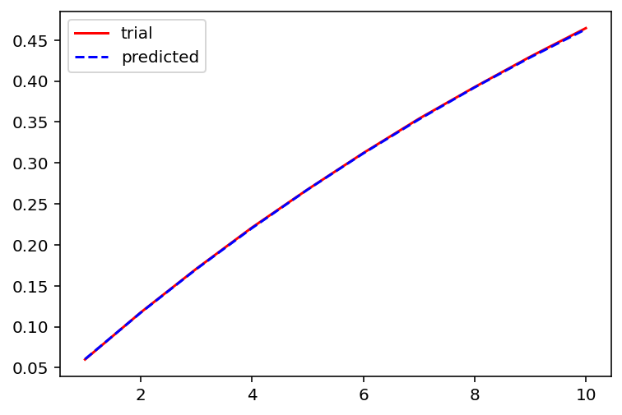

3 Robot
Relevant probabilities:
$$Pr\left(¬\left(1-2\right)∧¬\left(1-3\right)\right)={{\left(1-2S_{2}+S_{3}\right)}^{K}≜a^{K}}$$

$$Pr\left(\left.2 get information from 1\right.\right)= Pr\left((\left(2- 3\right)←(1-3))∨\left(1- 2\right))\right)$$
$$=\operatorname{Pr}\left(1-2\right)+\operatorname{Pr}\left(\left(\left(2- 3\right)←\left(1-3\right)\right)∧¬\left(1-2\right)\right)$$
$$=\operatorname{Pr}\left(1-2\right)+\sum_{k=1 }^{K}{\operatorname{Pr}\left(¬\left(1-3\right)∧¬\left(1-2\right)withink-1\right)\operatorname{Pr}\left(1-2atk\right)\operatorname{Pr}\left(2-3,¬\left(1-2\right)from k to K\right)}$$
$$=\left(1-{\left(1-S_{2}\right)}^{K}\right)+\sum_{k=1 }^{K}{a^{k-1}\left(S_{2}-S_{3}\right){(\left(1-S_{2}\right)}^{K-k}-a^{K-k})}$$
Single source:
$$\operatorname{Pr}\left(\left(2 get information from 1\right)∧ \left(3 get information from 1\right) \right) \\ =\operatorname{Pr}\left((\left(2- 3\right)←(1-3))∨\left(2- 1\right))∧ (\left(2- 3\right)←(1-2))∨\left(3- 1\right) \right)$$
Split “union” into “sum – intersection”
$$=2Pr\left((\left(2- 3\right)←(1-3))∨\left(2- 1\right))\right)-\operatorname{Pr}\left((\left(2- 3\right)←(1-3))∨\left(2- 1\right))∨ (\left(2- 3\right)←(1-2))∨\left(3- 1\right) \right)$$
$$=2Pr\left((\left(2- 3\right)←(1-3))∨\left(2- 1\right))\right)-\operatorname{Pr}\left(\left(1- 2\right)∨ \left(1- 3\right) \right)$$
$$=2\left(1-{\left(1-S_{2}\right)}^{K}\right)+2\left(\sum_{k=2}^{K}{a^{k-1}\left(S_{2}-S_{3}\right)\left({\left(1-S_{2}\right)}^{K-k}-a^{K-k}\right)}\right)-\left(1-a^{K}\right)$$

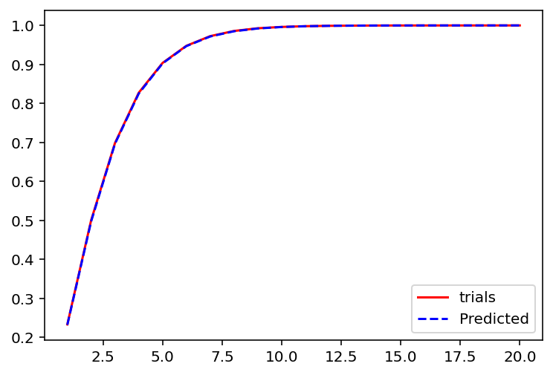
Multi-Source:
$$\operatorname{Pr}\left(\left(1 \text{percolation}\right)∧ \left(2 \text{percolation}\right)∧ \left(3 \text{percolation}\right)\right)$$
$$=Pr\left(\begin{matrix}((\left(2- 3\right)←(1-3))∨\left(2- 1\right))∧ ((\left(2- 3\right)←(1-2))∨\left(1- 3)\right) \\ ∧ \\ ((\left(1- 3\right)←(2-3))∨\left(2- 1\right))∧ ((\left(1- 3\right)←(1-2))∨\left(2- 3)\right) \\ ∧ \\ ((\left(1- 2\right)←(1-3))∨\left(2- 3\right))∧ ((\left(1- 2\right)←(2-3))∨\left(1- 3)\right)\end{matrix}\right)$$
$=Pr\left(\begin{matrix}\left(\left(2-3\right)←\left(1-3\right)\right)∧\left(\left(1-3\right)←\left(2-3\right)\right) \\ ∨ \\ \left(\left(2-3\right)←\left(1-2\right)\right)∧\left(\left(1-2\right)←\left(2-3\right)\right) \\ ∨ \\ \left(\left(1-3\right)←\left(1-2\right)\right)∧\left(\left(1-2\right)←\left(1-3\right)\right) \\ ∨ \\ \left(1-2\right)∧\left(1-3\right)∧\left(2-3\right) \end{matrix}\right)$一
$$=3Pr\left(\left(\left(2-3\right)←\left(1-3\right)\right)∧\left(\left(1-3\right)←\left(2-3\right)\right)∧¬\left(1-2\right)\right)+Pr(\left(1-2\right)∧\left(1-3\right)∧\left(2-3\right))$$
(1 pair never met) * (3 possible pairs) + (all 3 met each other)
$$=\left[3\sum_{k=1}^{K}{2\left(a^{k-1}-{\left(1-3S_{2}+2S_{3}\right)}^{k-1}\right)\left(S_{2}-S_{3}\right){\left(1-S_{2}\right)}^{K-k}-a^{K-k })}\right]+\left[1-3{\left(1-S_{2}\right)}^{K}+3a^{K}-{\left(1-3S_{2}+2S_{3}\right)}^{K}\right]$$
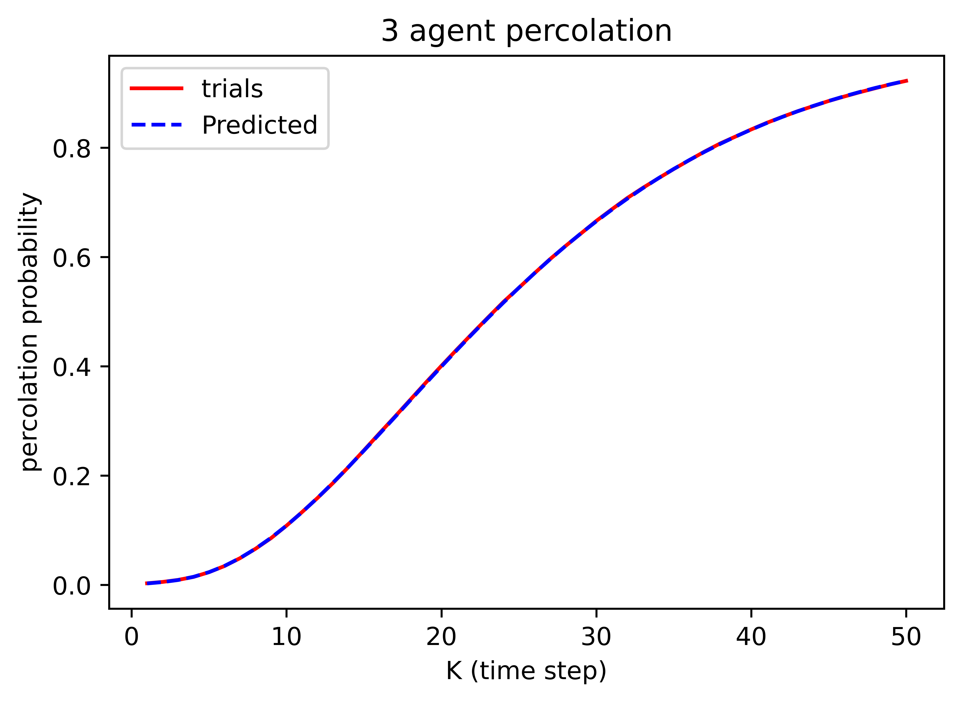

N-robot system
$$Pr\left(1 meet 2 within K∧ 2 meet 3 within K ∧ ⋯\right)$$
$$=1-Pr\left(1 not meet 2 within K∨ 2 not meet 3 within K ∨ ⋯\right)$$
$$=1-Pr\left(1 not meet 2 within K∨ 2 not meet 3 within K ∨ ⋯\right)$$
$$=1-C_{1}^{N}Pr\left(i not meet j within K\right)+C_{2}^{N}Pr\left(i notmeet j,j not meet k within K\right)-⋯$$
$$=1-C_{1}^{N}{Pr\left(i not meet j at k\right)}^{K}+C_{2}^{N}Pr\left({\left(i not meet j,j not meet k at k\right)}^{K}\right)-⋯$$
$$=1-C_{1}^{N}Pr{\left(1 pair not meet at k\right)}^{K}+C_{2}^{N}Pr{\left(2 pair not meet at k\right)}^{K}-⋯$$
$$≈1-C_{1}^{N}{Pr\left(1 pair not meet at k\right)}^{K}+C_{2}^{N}Pr{\left(1 pair not meet at k\right)}^{2K}-⋯$$
$$=1-C_{1}^{N}{Pr\left(1 pair not meet at k\right)}^{K}+C_{2}^{N}{\left(Pr{\left(1 pair not meet at k\right)}^{K}\right)}^{2}-⋯$$
$$=\sum_{r=0}^{N}{{\left(-1\right)}^{r}{\left({Pr\left(1 pair not meet at k\right)}^{K}\right)}^{r}}$$
$$={\left(1-{Pr\left(1 pair not meet at k\right)}^{K}\right)}^{N}$$
$$={\left(1-{\left(1-S_{2}\right)}^{K}\right)}^{N}$$

